**Day-11 Full Stack**

By default position: static

Relative: current position ke according move karega

Top, bottom, left, right ke according hum move kar skte hai element.

Absolute: move with respect to parent.

Fixed: always be fixed that element

Sticky: move in certain range;

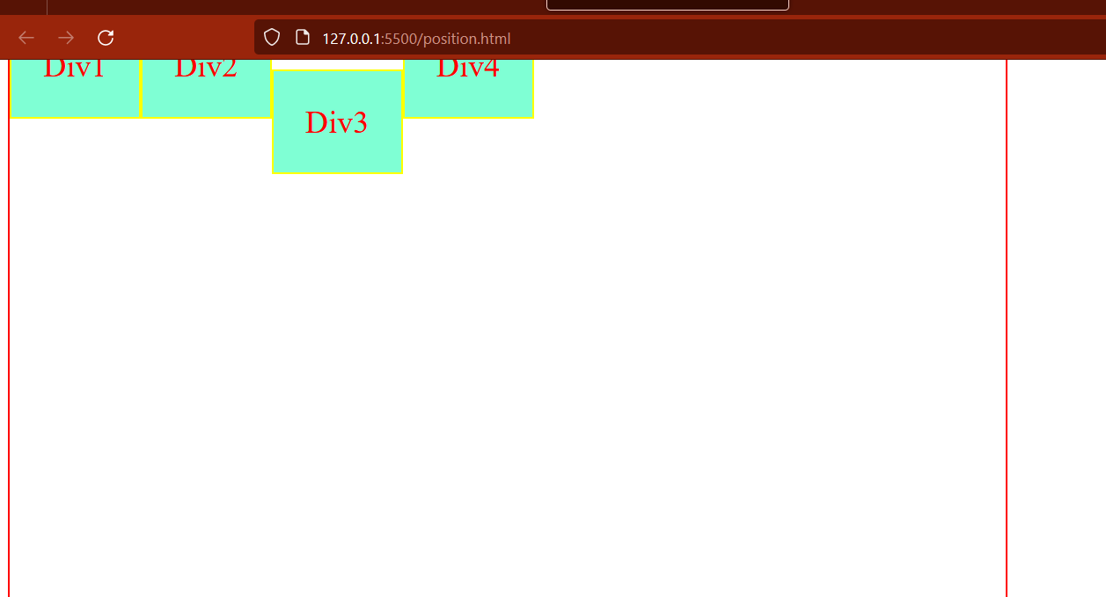

Float to left:

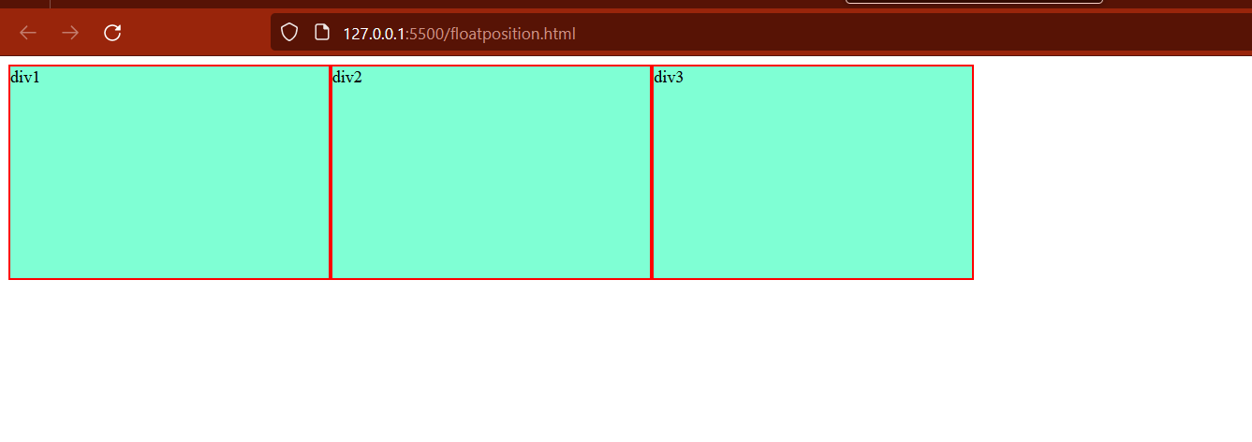

div {

  /* float: left; */

  background-color: aquamarine;

  border: 2px solid red;

  height: 200px;

  width: 300px;

}

.div1 {

  float: left;

  background-color: red;

}

.div2 {

  float: right;

  background-color: black;

}

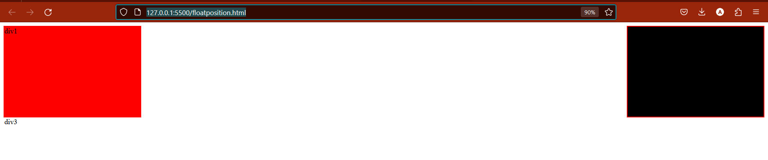

Flexbox:

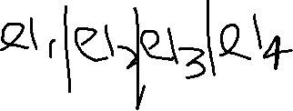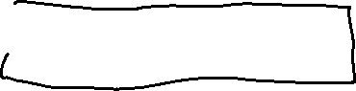

**Parent property:**

**Display:flex**

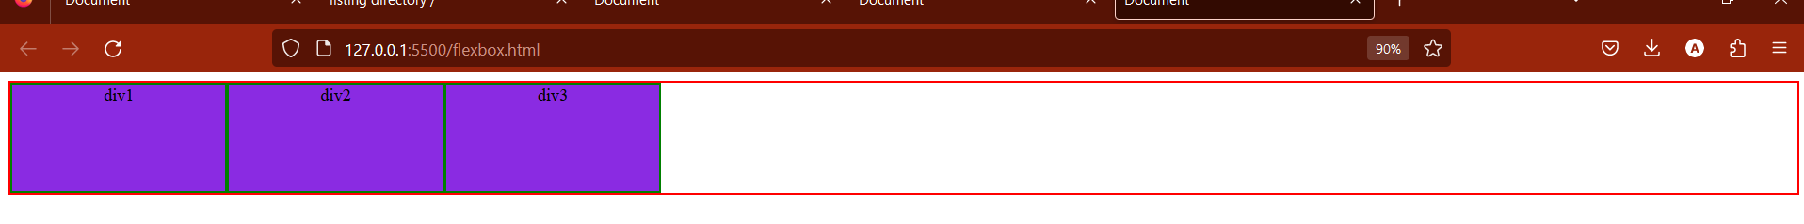

**Flex-direction:**

1)By default row

2)column

3)Row-reverse

4)Column-reverse

**For default property for display:flex in parent**

Justify-content property along regular axis

1)justify-content:start by default property

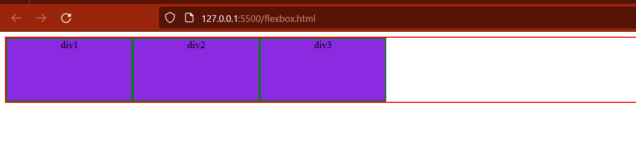

2)justify-content:center

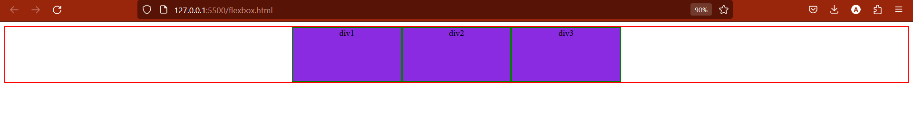

3)justify-content:space-around

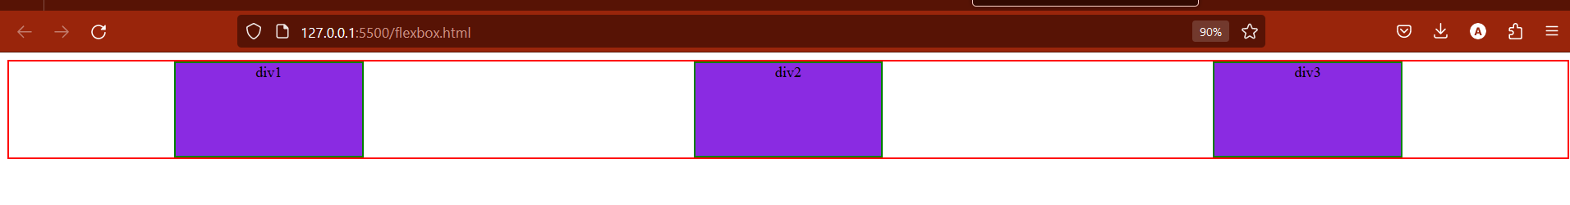

**Align-items property along cross axis:**

By default align-items:start

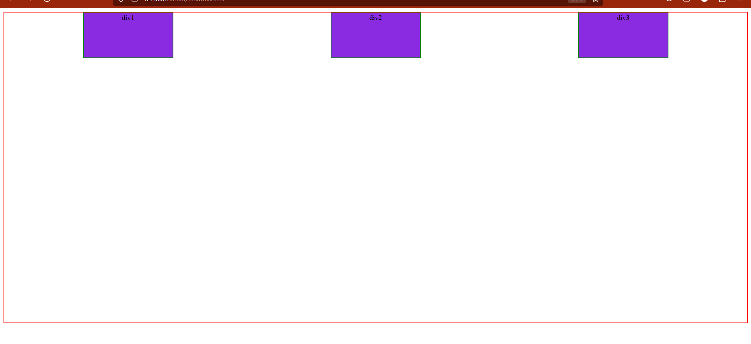Align-items:end

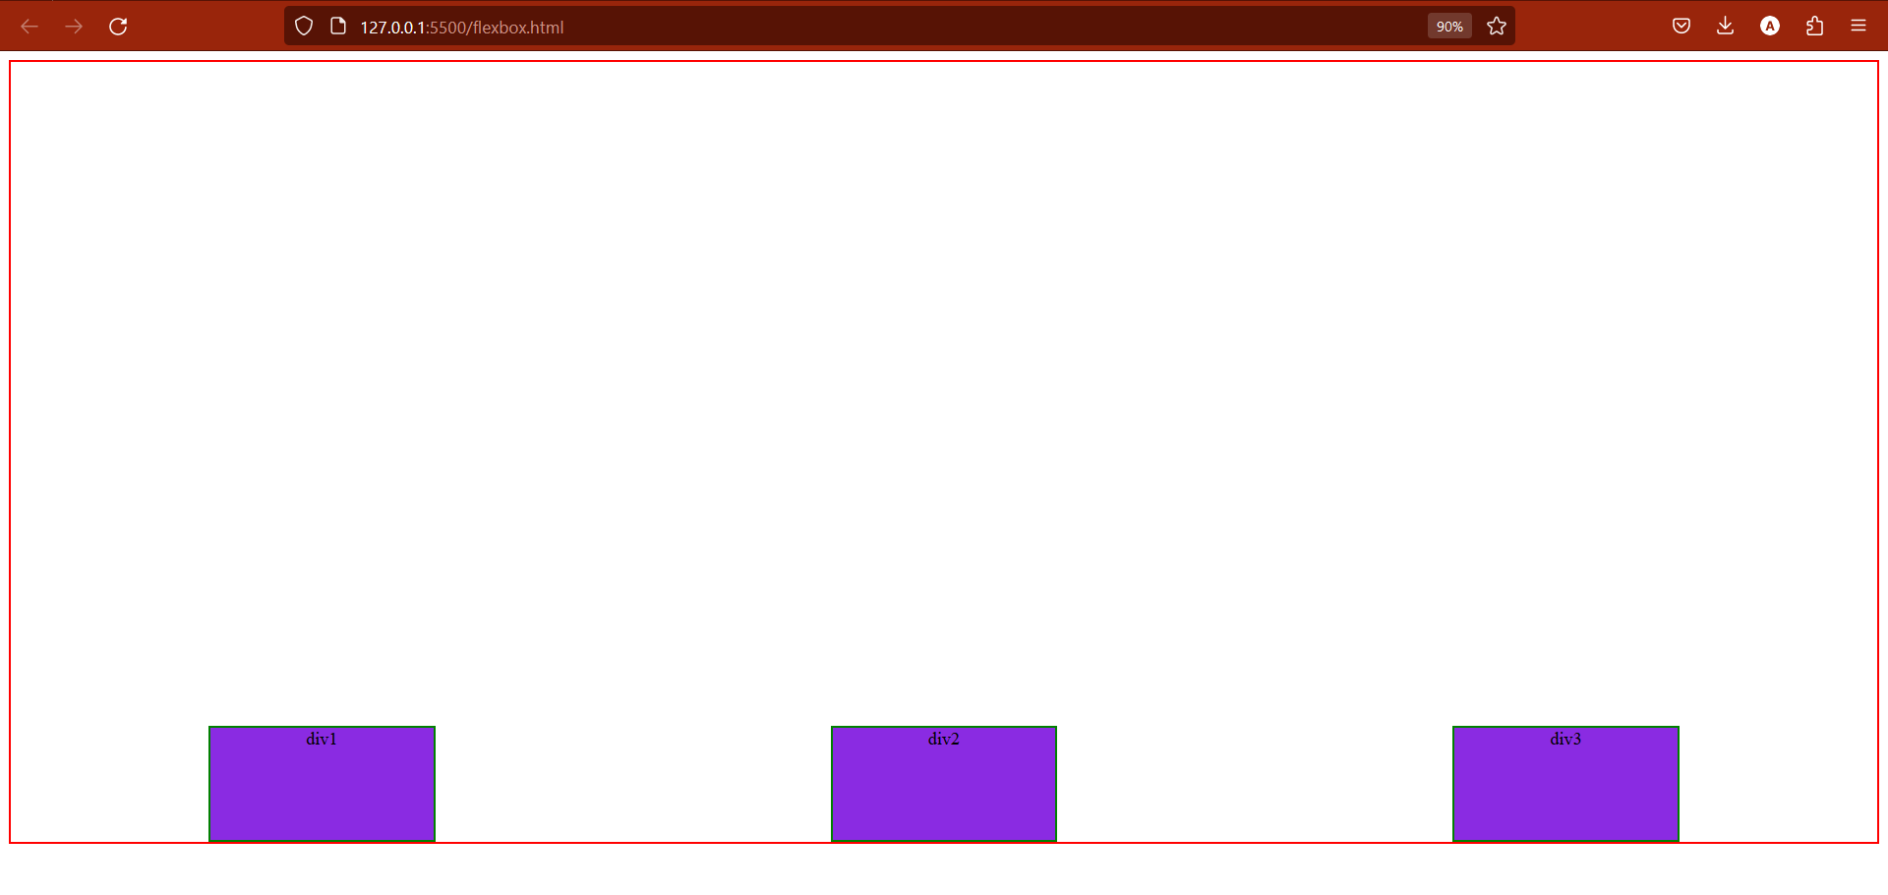

Align-items:stretch

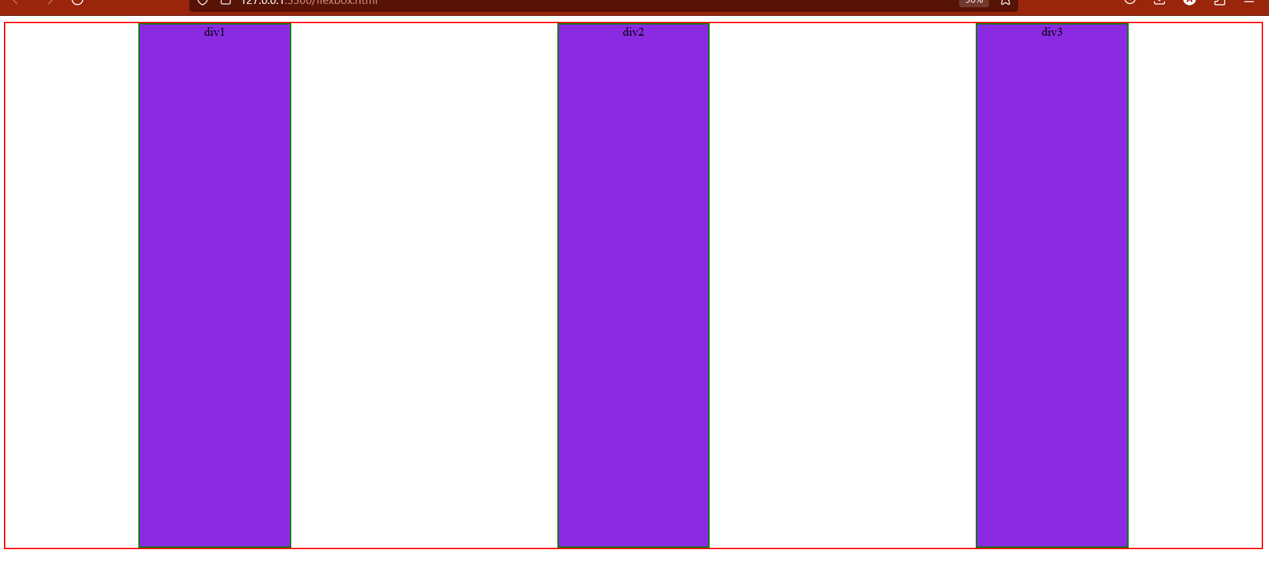

Note: but when we specify height of child in this case child element not stretch.

**Flex-wrap property:**

**By default flex-wrap: nowrap**

1)flex-wrap:wrap;

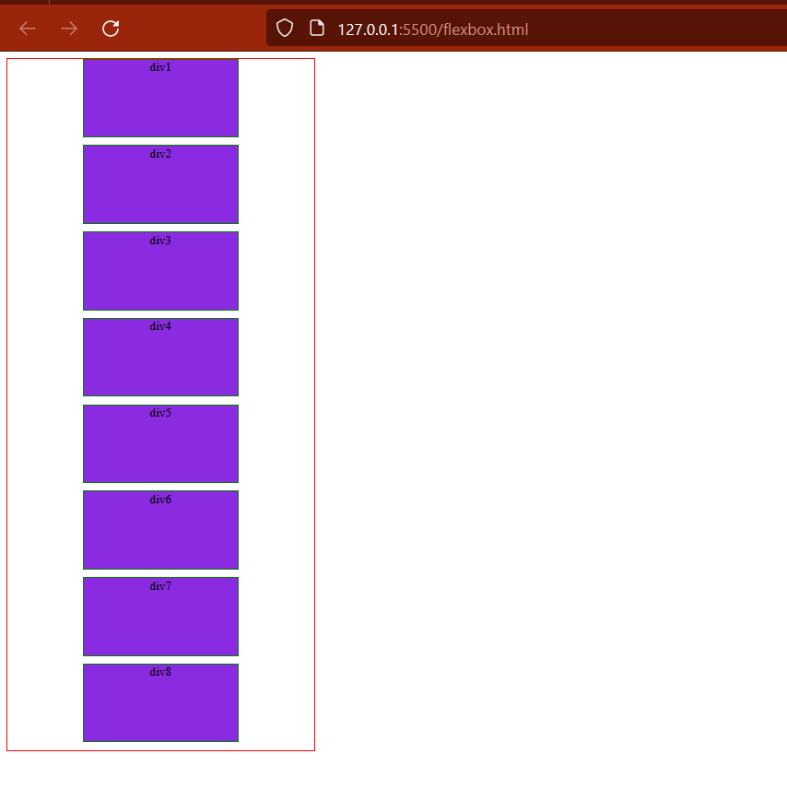

**Align-content property: only used when wrapping use with respect to cross axis:**

1)align-content by default

2)align-content :space around

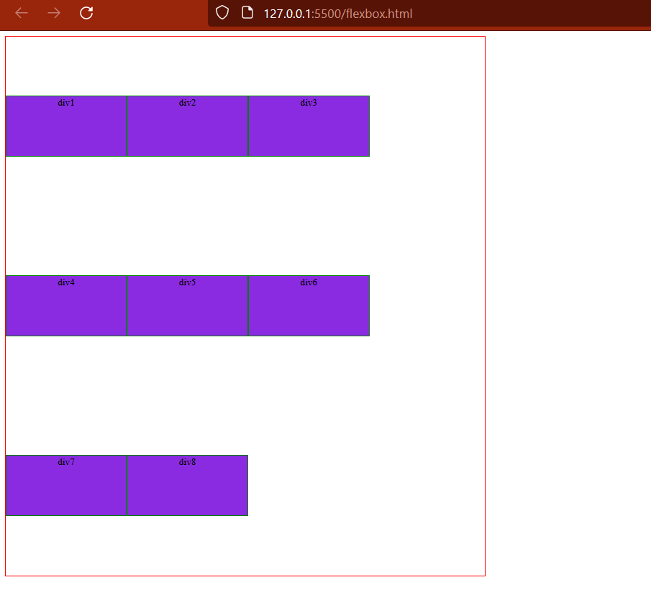

**Row-gap property:**

Row-gap:1rem;

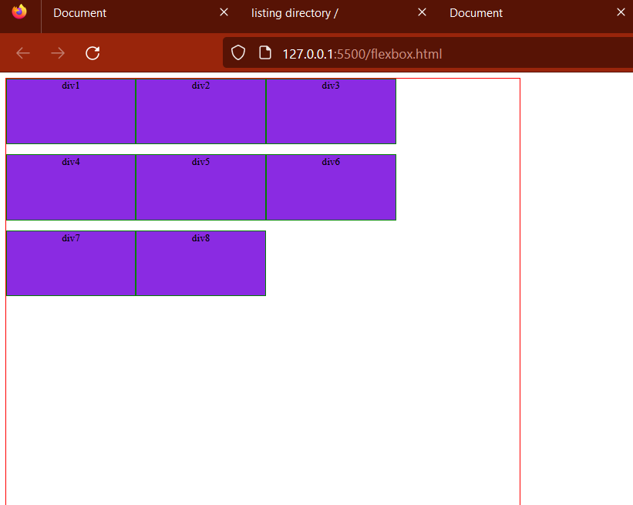

**Column-gap property:**

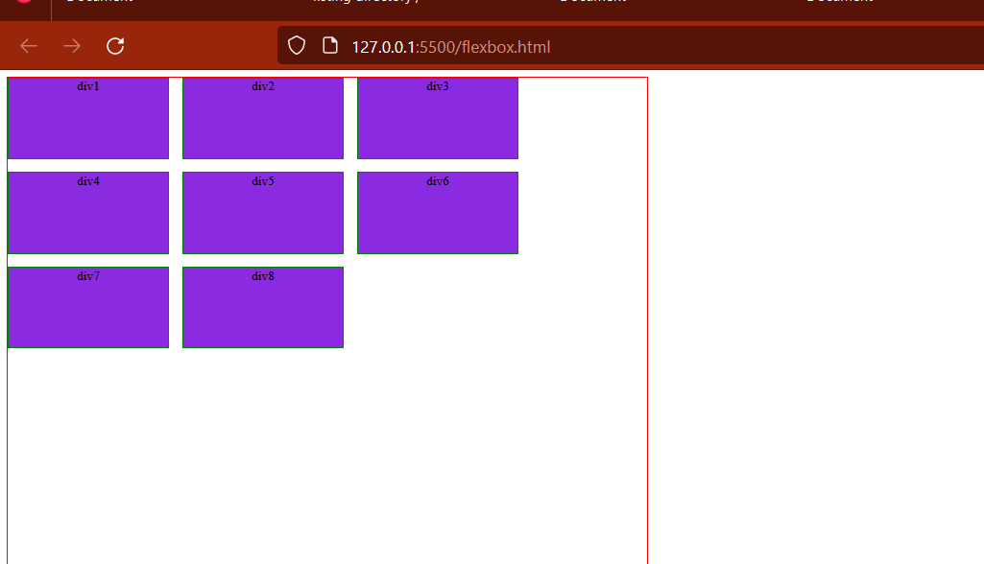

**Shorthand notation for flex-direction and flex-wrap:**

**Flex-wrap:column wrap;**

**All property of parents:**

*Display:flex;*

*Flex-direction:row/column*

*Flex-wrap:wrap/nowrap*

*Flex-flow:column wrap*

*Justify-content:*

*Align-items:*

*Align-content:*

*Row-gap:*

*Column-gap:*

*Gap: row column*

**Child Property:**

**Flex-grow property:**

Flex-grow:1

Equally grow

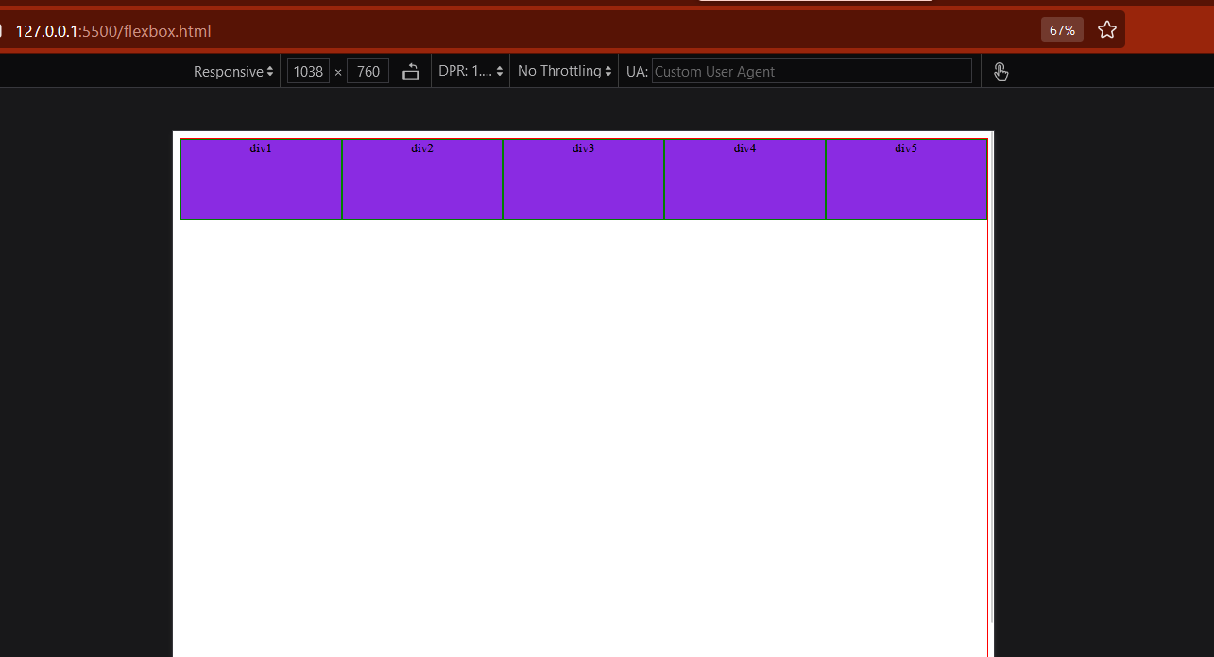

**.col1{**

**Flex-grow:3;**

**}**

**Flex-shrink property:**

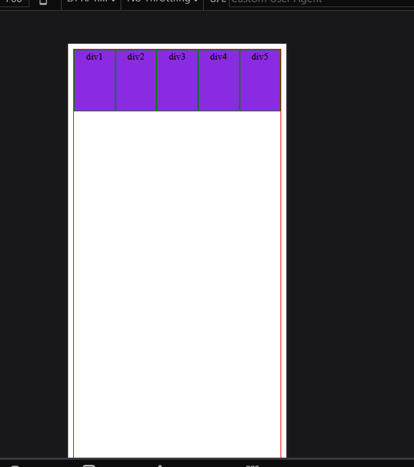

**Agar data overflow parent ka ja rha hai to use shrink krne ka property hot hai flex-shrink ka.**

**Flex-shrink:0 means kuch bhi jaye shrink mat krna**

**Flex-basis property:**

Flex-basis:x%;

Only take x% space according to given one.

**Css:**

.container {

  display: flex;

  flex-wrap: wrap;

  background-color: aqua;

  border: 2px solid red;

  height: 400px;

}

.container > * {

  flex: 0 1 100%;

  /* grow shrink basis */

  border: 2px solid black;

}

**Html:**

    <div class="container">

      <header class="header">header</header>

      <article class="content">Articlle</article>

      <aside class="aside1 aside">Aside1</aside>

      <aside class="aside2 aside">Aside2</aside>

      <footer class="footer">footer</footer>

    </div>

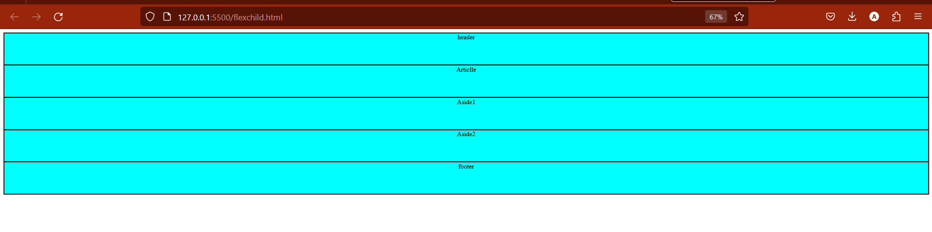

**Css:**

.container {

  display: flex;

  flex-wrap: wrap;

  background-color: aqua;

  border: 2px solid red;

  height: 400px;

  /* align-items: center; */

}

.container > * {

  flex: 0 1 10%;

  /* grow shrink basis */

  border: 2px solid black;

  text-align: center;

}

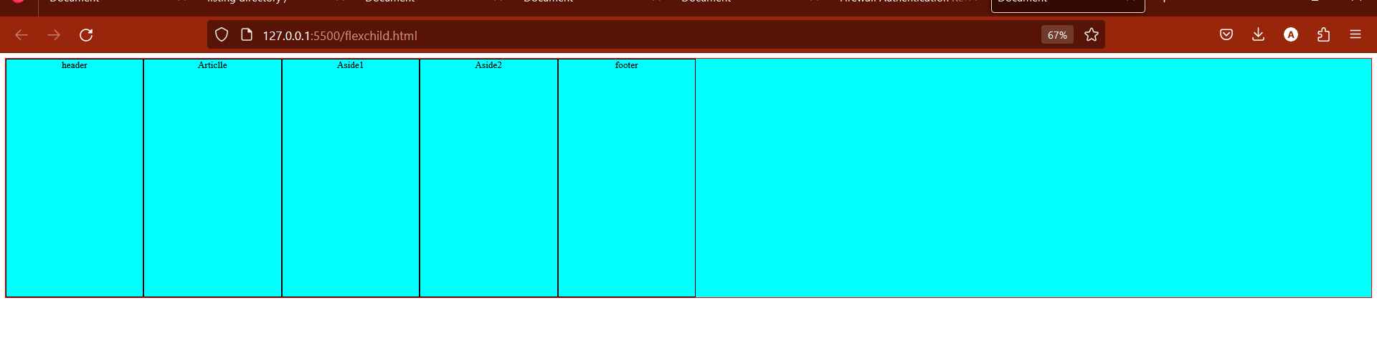

**Revise Property:**

Parent Property:

1)display:flex;

2)flex-wrap: nowrap/wrap;

=>flex-wrap:nowrap; /*By default*/

=>flex-wrap:wrap;

.container {

  background-color: aquamarine;

  border: 2px solid red;

  text-align: center;

  display: flex;

  width: 405px;

  flex-wrap: wrap;

}

.container > * {

  border: 2px solid black;

  width: 95px;

}

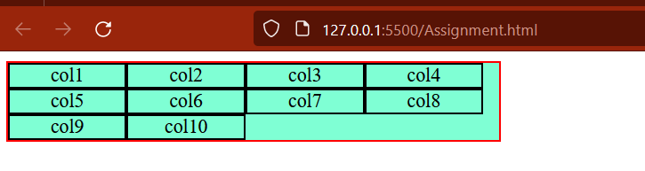

=>flex-wrap:wrap-reverse;

3.flex-direction:row; /* By default */

=>flex-direction:row-reverse;

=>flex-direction:column;

Flex-direction:column-reverse;

4.justify-content:start;/* By default */



=>justify-content:center;



=>justify-content:end;

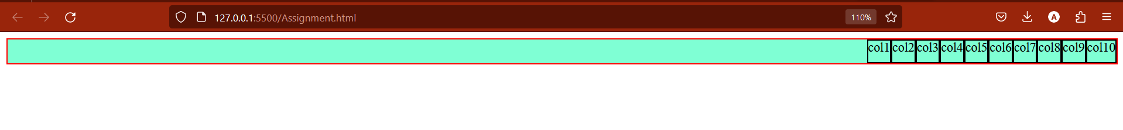

=>justify-content:space-around;

=>justify-content:space-between;



=>justify-content:left;



5.align-items:start;

=>align-items:center;

=>align-items:end;

6. align-content: end;

Work with main axis just like justify content work with cross-axis.

=>align-content:center;

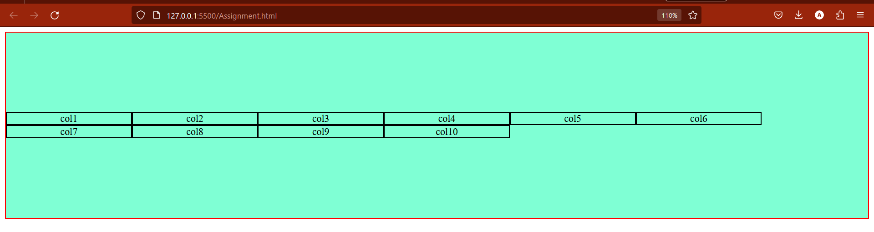

7.row-gap:20px;

8.column-gap:30px;

For Understanding flex-basis first look the border-box property:

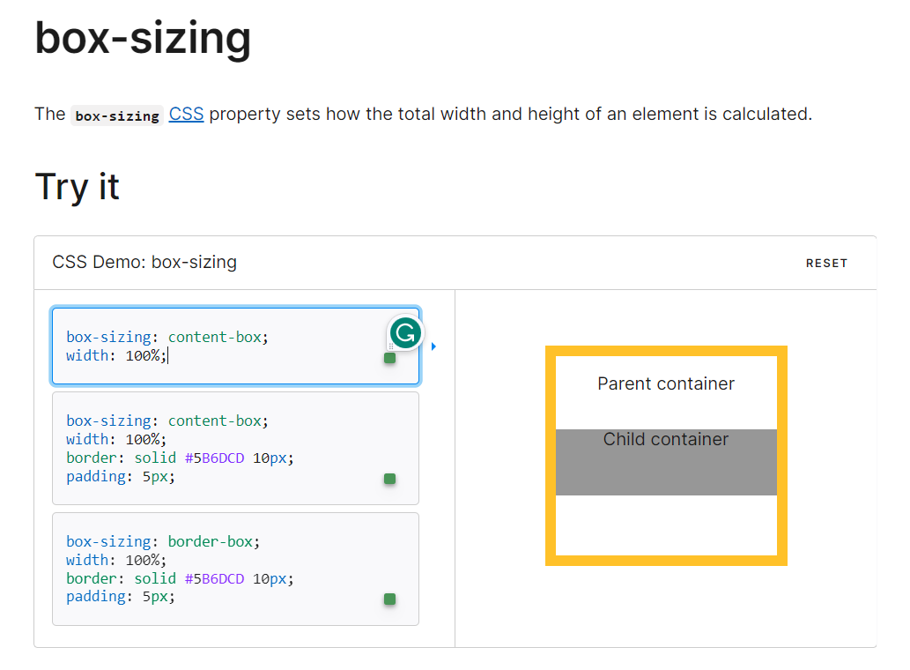

**Child Property of flex:**

1.flex-basis:100px;

.col1{

Flex-basis:400px;

.col1{

Flex-basis:100%;

}

2.flex-grow:

.col1 {

  /* flex-basis: 100%; */

  flex-grow: 2;

}

.col2 {

  flex-grow: 3;

}

3.flex-shrink:

.col1 {

  /* flex-basis: 100%; */

  flex-shrink: 2;

}

.col2 {

  flex-shrink: 3;

}